**ME 354**

Tensile Test Formal Report

Konsta Jäske

Section AB

# Abstract

This lab examines the tensile properties of three common engineering materials: two types of metals, A36 (hot-rolled) steel and 6061-T6 aluminum, and a unidirectional carbon fiber reinforced polymer (CFRP). It is desirable to know the material properties of these materials so that they can be used for design purposes reliably. Tensile dogbone specimens were made for the metal specimens, and rectangular tension specimens of the CFRP in 0º and 90º orientations were made using bonded fiberglass tabs. The tests were conducted according to ASTM standards for metals and composites. The steel specimens were found to have an elastic modulus of 163 ± 16.6 GPA, a yield strength of 334 ± 5.57 MPa, and poisson’s ratio of 0.268 ± 0.0814. The steel was observed to fail in a ductile manner at 35.6 ± 1.67 % elongation. The aluminum specimens were found to have an elastic modulus of 71.9 ± 4.30 GPa, a yield strength of 299 ± 2.63 MPa, and a poisson’s ratio of 0.313 ± 0.021. The aluminum was observed to fail in a ductile manner at 11.7 ± 0.0072 % elongation. The 0 degree CFRP specimens were found to have an elastic modulus of 179 ± 39.6 GPa, a yield/fracture stress of 2890 ± 137.9 MPa, and a poisson’s ratio of 0.4 ± 0.006. The 0 degree CFRP was observed to fail in a brittle manner at 0% elongation. The 90 degree CFRP specimens were found to have an elastic modulus of 8.93 ± 0.703 GPa, a yield/fracture stress of 74.1 ± 9.72 MPa, and a poisson’s ratio of 0.0257 ± 0.0118. These results primarily skew heavily from the provided tabulated data. The results from our derivations show that 6061-T6 aluminum is best used when a high strength to weight ratio is needed and that A36 steel is best used when ultimate stress and toughness are of primary concern. We recommend that CFRP be used in applications where exclusively uniaxial loading is expected and rigidity is of high priority.

# Introduction

A uniaxial tension test is one of the most heavily utilized methods for characterizing material performance. It is from a uniaxial tension test that we obtain quantities such as Young’s modulus, Poisson’s ratio and yield strength. Due to the prevalence of these tests, there are well documented methods and standards which must be followed for different materials systems, such as ASTM E8/E8M [1] for metal testing and ASTM D3039 [2] for polymer matrix composite testing.

In this lab, we have used an Instron mechanical testing system to perform a uniaxial tension test on 3 different materials: A36 steel, 6061-T6 aluminum and a unidirectional carbon fiber reinforced polymer. These materials are used in a wide range of engineering applications, so it is desirable that we understand their behavior. 6061 T6 aluminum is one of the most common alloys of aluminum for general-purpose use, and one of the most common engineering materials in the world. It exhibits greats weldability and formability and is used in structural applications as well as machine parts. As this alloy may be used in safety critical applications, it is imperative that we understand its behavior. A36 steel is a common structural steel in the United States, so understanding its properties is a requirement to build safe structures. Carbon fiber reinforced polymers are often used when high strength to weight ratio is a requirement; thus such materials are widespread in the aerospace industry

From these tests, we have characterized important material properties such as Young’s modulus, Poisson’s ratio and yield strength. For any given material, there will be some statistical variation in the properties based on how the measurements are taken. For this reason, we have also obtained statistical averages and found standard deviations on all the material properties here. This is important in our engineering analysis because in order to use these materials safely we must understand the limits of our measurements so we can adjust our factors of safety accordingly. It would be negligent to forgo the statistical analysis in this report and not inform the reader that our calculations are subject to variation.

## Theory

From the uniaxial tension tests, we have characterized a range of material properties. For the whole test, we have obtained the axial engineering stress ($σ$) and strain ($ε$) behavior, the axial true stress ($σ_{t}$) and strain ($ε_{t}$) behavior and the transverse engineering strain ($ε_{trans}$). These are defined relative to the applied force F, initial area $A_{o}$, initial length $L_{o}$, initial width $W_{0}$, instantaneous width W, instantaneous area $A$ and instantaneous length $L$ as

|  |  |  |
| --- | --- | --- |
|  | $$σ=\frac{F}{A_{o}}$$ | Eq. 1 |

|  |  |  |
| --- | --- | --- |
|  |  | Eq. 2 |

|  |  |  |
| --- | --- | --- |
|  |  | Eq. 3 |

|  |  |  |
| --- | --- | --- |
|  |  | Eq. 4 |

|  |  |  |
| --- | --- | --- |
|  |  | Eq. 5 |

The instantaneous length is determined using the displacement, and the instantaneous area can be found from the transverse strain as

|  |  |  |
| --- | --- | --- |
|  | $$A={(1+ε_{trans})}^{2}A_{o}$$ | Eq. 6 |

It should be noted that the true stress and strain are only valid prior to necking, as the instantaneous area of the specimen is difficult to accurately measure throughout the duration of the test.

Two material properties, the Young’s modulus and Poisson’s ratio, are found using the slope of the material’s stress-strain data and ratio of transverse strain to axial strain in the elastic regime. Two metrics for the energy dissipation, the modulus of resilience ($U_{R}$) and the tensile toughness ($U_{f}$), are found by integrating the stress-strain curve from zero to the elastic limit and from zero to the fracture strain, respectively.

|  |  |  |
| --- | --- | --- |
|  | $$U_{R}=\frac{σ_{y}ε_{y}}{2}$$ | Eq. 7 |

|  |  |  |
| --- | --- | --- |
|  |  | Eq. 8 |

## Materials

Three materials have been tested as part of this experiment, including two metals and one carbon fiber reinforced polymer (CFRP). The metals are hot rolled A36 steel and 6061-T6 aluminum. The composite is made from an IM7 carbon fiber and a CYCOM 5250-4 epoxy resin and with a $V_{f}=65\%$ volume fraction of fibers. Some approximate properties have been provided by the manufacturers, and these are listed in Table 1.

***Table 1****: Properties of the materials tested.*

|  |  |  |  |  |
| --- | --- | --- | --- | --- |
| **Material** | $$E (GPa)$$ | $$σ_{y} (MPa)$$ | $$ν$$ | $$ρ (kg/m^{3})$$ |
| 6061-T6 Aluminum | 69 | 275 | 0.33 | 2.7 |
| A36 Steel | 200 | 250 | 0.26 | 7.82 |
| Carbon Fiber (IM7) | 276 | 5585 | 0.28* | 1.78 |
| CYCOM 5250-4 (BMI Resin) | 4.6 | 103 | 0.39* | 1.25 |

*Note: These values are approximate based on the properties of other similar materials. They were not made available in the manufacturer data sheet as vendor did not provide the information.

### Carbon Fiber Composite Properties

The properties of the CFRP can be determined based on the ratio of fibers to epoxy resin in the composite. The CFRP behaves differently in the longitudinal and transverse directions relative to the orientation of the fibers and exhibits different stiffnesses and strengths in these directions. Under the assumption that the fibers and matrix are subjected to equal strain with a longitudinally applied load and equal stress with a transversely applied load, we may generate formulations for the stiffness of the composite in each respective direction. The failure strength of the CFRP in the longitudinal orientation is primarily dictated by the failure strain of the fibers, while the failure in the transverse orientation is dictated by the strength of the matrix.

|  |  |  |
| --- | --- | --- |
|  | $$E_{1}=V_{f}E_{f}+(1-V_{f})E_{m}$$ | Eq. 9 |

|  |  |  |
| --- | --- | --- |
|  |  | Eq. 10 |

|  |  |  |
| --- | --- | --- |
|  |  | Eq. 11 |

|  |  |  |
| --- | --- | --- |
|  |  | Eq. 12 |

|  |  |  |
| --- | --- | --- |
|  |  | Eq. 13 |

|  |  |  |
| --- | --- | --- |
|  |  | Eq. 14 |

The predicted properties of the composite are presented in Table 2.

***Table 2****: Predicted properties of the CFRP composite.*

|  |  |
| --- | --- |
| **Property** | **Value** |
| $$E_{1}$$ | 181 GPa |
| $$E_{2}$$ | 12.7 GPa |
| $$σ_{1}$$ | 3.66 GPa |
| $$σ_{2}$$ | 103 MPa |
| $$ν_{12}$$ | 0.32 |
| $$ν_{21}$$ | 0.022 |

## 2.2 Experimental Setup and Procedure

The tension experiments were carried out in an Instron mechanical testing system (5585H Tensile Test Machine, Instron). The tension test of metal specimens were conducted according to ASTM E8/E8M standard, while the CFRP specimens were tested according to ASTM D3039/D3039M standard. In these processes specimens of ASTM specification are subjected to a varying tensile load to the point of fracture. The specimens’ gauge dimensions were measured and accounted for in the accompanying computer program. We marked a length of 50 mm on each specimen’s gauge section as a reference to determine the deformation of the specimen. The testing system’s load cell was balanced before each specimen was installed in the machine. The specimen was inserted into the lower grip and the crosshead was lowered such that the specimen was gripped at a 10 mm gap from the transition to the gauge section at both ends. Then we installed the axial and transverse extensometers and zeroed them. This completes the experimental setup, which is shown in figure 1.

The initial specimen length, dimensions, and initial extensometer gauge length were recorded in the software. We initiated the testing sequence in the computer’s testing program. Once the test completed and the specimen fractured, we removed the specimen from the grips and measured and recorded the final length between the markings we made earlier. We saved copies of the data file for each specimen’s test and used them for this report.

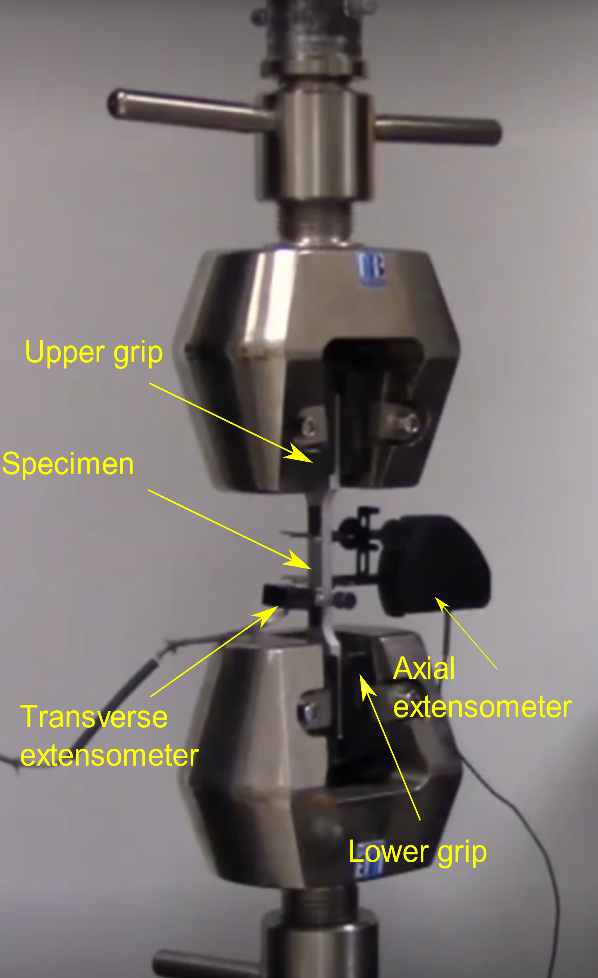

***Figure 1****: Picture of experimental set up with relevant components labeled.*

For the three materials tested, the metal specimens were prepared using a waterjet cutting system, while the CFRP specimens were prepared using a diamond saw. The dimensions of the specimens tested are provided in Table 2.

***Table 3****: Average specimen dimensions.*

|  |  |  |
| --- | --- | --- |
| **Specimen** | Thickness (mm) | Width (mm) |
| 6061-T6 Aluminum | 6.43 ± 0.025 | 12.15 ± 0.025 |
| A36 Steel | 6.21 ± 0.025 | 12.30 ± 0.025 |
| CFRP - 0° | 1.04± 0.025 | 18.49 ± 0.025 |
| CFRP - 90° | 2.24 ± 0.025 | 18.74 ± 0.025 |

# Results

## 6061-T6 Aluminum Results

In the aluminum specimen tests, the samples began to depart the elastic regime at around 0.004 axial strain. After this the specimens plastically deformed at a steady rate until the applied force reached a maximum and subsequently started to decrease. This is when the specimens started to neck and eventually fractured. Pictured below is one aluminum specimen before and after fracture, respectively.

***Figure 1.*** *Picture of the 6061-T6 aluminum before testing.*

***Figure 2.*** *Picture of the 6061-T6 aluminum after testing.*

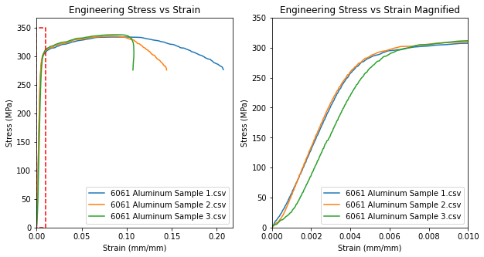

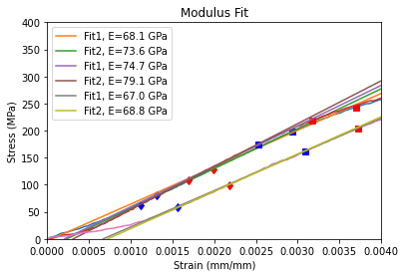

***Figure 3.*** *Plots of the stress-strain results for the 6061-T6 aluminum specimens along with fits for the modulus.*

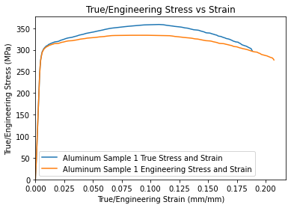

***Figure 4.*** *Representative plot of the engineering vs true stress-strain for 6061-T6 aluminum.*

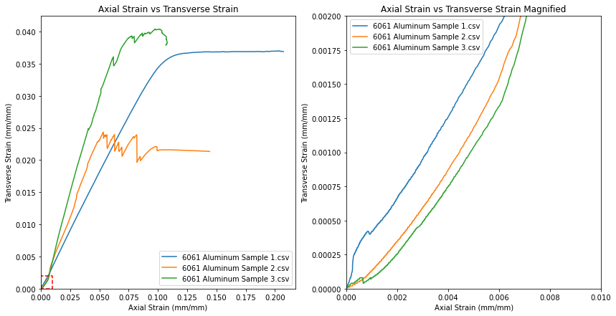

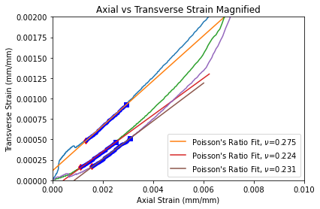

***Figure 5.*** *Representative plots of the axial vs. transverse strains of 6061-T6 aluminum along with fits for Poisson’s ratio.*

Figure 3 shows the tensile test results of the three 6061-T6 aluminum specimens. The third graph displays two linear regression fits of each specimen’s dataset to approximate the elastic moduli of the samples. The linear regressions were attained using the Python module scipy’s function “linregress”; the reader may find the associated code for these calculations and all calculations discussed hereafter in the appendix. The linear fits for each specimen were constrained to the linear-elastic region of the specimen’s stress-strain curve. The average and standard deviation of the six fits were calculated. Figure 4 shows the true stress/strain and engineering stress/strain curves of the same specimen. The engineering stress was calculated by dividing the load readings by the initial cross-sectional area of the specimen being tested, and the testing software calculated the axial strain with the extensometer readings and user-provided initial length. The true stress was found by dividing the applied load by the instantaneous area of the specimen as calculated using equation 6 and the transverse extensometer readings. True strain was calculated using the axial strain readings and equation 4.

The poisson’s ratio of each specimen was approximated by calculating the linear regression of the ratio of transverse strain to axial strain for each specimen. The linear fits were constrained to the linear-elastic region of each specimen’s stress-strain curve and were adjusted to not include the anomalous data observed at the start of each test as shown in the second graph in figure 5. The average and standard deviation of the specimens’ poisson’s values were calculated. The yield strength of each specimen was approximated by first constructing a line with the slope of the approximated elastic modulus and offsetting it by 0.002 strain. The intersection of this line with the stress-strain curve of the specimen gives the yield strength and strain of the material. A single yield strength value was calculated for each sample, and the average and standard deviation of the three values was calculated. The ultimate tensile strain was obtained by finding the largest stress value in each test dataset, and the corresponding ultimate strain was found at the same data point index as the ultimate stress.

The percent elongation of each specimen was calculated by dividing the total change in length of the specimen by the initial length of the specimen, for example for the first aluminum sample the calculation was $\%= \frac{55.8 mm-50 mm}{50 mm}=11.6\%$. The average and standard deviation of three elongation values were calculated. The specific stiffness and strength were calculated by dividing the approximated E and $σ_{y}$ values with the nominal density. The fracture stress and strain of each specimen were obtained by observing the tail end of the test data and identifying the point at which the specimen failed. This point always preceded a sudden drop in load and strain due to fracture by one data point. The average and standard deviation of the fracture stresses and strains was evaluated. The modulus of resilience was calculated by integrating the stress-strain curve of each specimen from zero strain to the yield strain using a trapezoidal integration scheme. The average and standard deviation of the moduli was calculated. The tensile toughness was calculated by integrating the stress-strain curve of each specimen from zero strain to the fracture strain using a trapezoidal integration scheme. The average and standard deviation of the moduli was calculated. The calculated properties below do not account for error inherent to the measured dimensions of each sample, as the contribution of these errors was found to be insignificant.

***Table 4.*** *Measured properties of the 6061-T6**aluminum.*

|  |  |
| --- | --- |
| **Properties** | **Values** |
| Young’s modulus, $E$ (GPa) | 71.9 ± 4.30 |
| Poisson’s ratio, $ν$ | 0.313 ± 0.021 |
| Yield Strength, $σ_{y}$ (MPa) | 299 ± 2.63 |
| UTS (MPa) | 335 ± 1.69 |
| Ultimate Strain, $ε_{ult}$ (mm/mm) | 0.088 ± 0.0038 |
| % of elongation (%) | 11.7 ± 0.0072 |
| Specific stiffness, $E/ρ$ ($\frac{m^{2}}{s^{2}}$) | 26.63E9 ± 1.59E9 |
| Specific strength, $σ_{y}/ρ$ ($\frac{m^{2}}{s^{2}}$) | 111E6± 0.974E6 |
| Fracture Stress (MPa) | 276 ± 0.286 |
| Fracture Strain (mm/mm) | 0.153 ± 0.0414 |
| Modulus of resilience (MPa) | 1.17 ± 0.058 |
| Tensile Toughness (MPa) | 48.5 ± 12.9 |

## A36 Steel Results

In the steel specimen tests, the samples began to depart the elastic regime at around 0.002 axial strain, where the load-strain curve reached a peak and a subsequent flat area where the specimen experienced increasing strain with no increase in applied load. After this the specimens plastically deformed and the applied force increased significantly until the force reached a maximum and subsequently started to decrease. This is when the specimens started to neck and eventually fractured. Pictured below is one steel specimen before and after fracture, respectively.

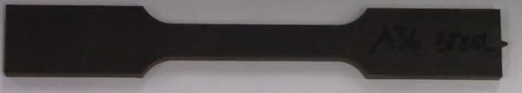

***Figure 6.*** *Picture of the A36 steel before testing.*

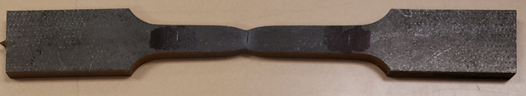

***Figure 7.*** *Picture of the A36 steel after testing.*

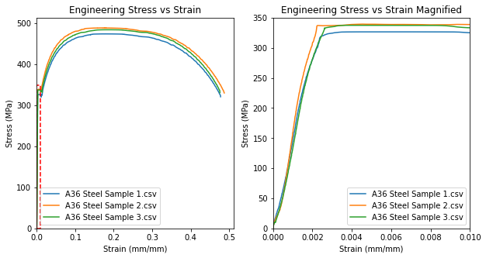

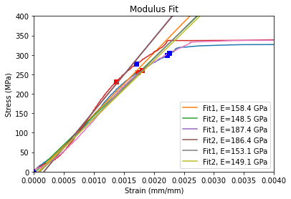

***Figure 8.*** *Plots of the stress-strain results for the A36 steel specimens along with fits for the modulus.*

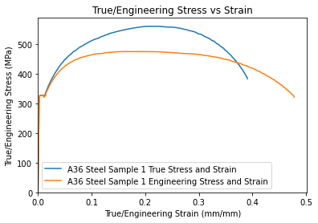

***Figure 9.*** *Representative plot of the engineering vs true stress-strain for A36 steel.*

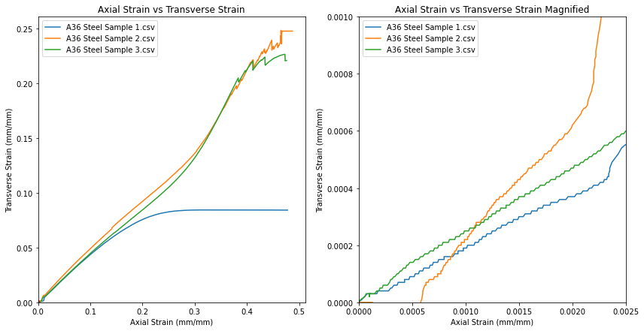

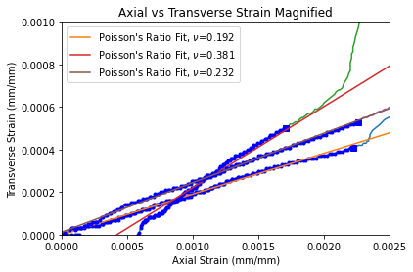

***Figure 10.*** *Representative plot of the axial vs. transverse strains of A36 steel along with fits for Poisson’s ratio.*

The properties’ values and errors displayed in table 5 were calculated in the same manner as described in section 3.1.

***Table 5.*** *Measured properties of the A36 steel.*

|  |  |
| --- | --- |
| **Properties** | **Values** |
| Young’s modulus, $E$ (GPa) | 163 ± 16.6 |
| Poisson’s ratio, $ν$ | 0.268 ± 0.0814 |
| Yield Strength, $σ_{y}$ (MPa) | 334 ± 5.57 |
| UTS (MPa) | 482 ± 6.14 |
| Ultimate Strain, $ε_{ult}$ (mm/mm) | 0.181 ± 0.00467 |
| % of elongation (%) | 35.6 ± 1.67 |
| Specific stiffness, $E/ρ$ ($\frac{m^{2}}{s^{2}}$) | 20.8E9 ± 2.12E9 |
| Specific strength, $σ_{y}/ρ$ ($\frac{m^{2}}{s^{2}}$) | 42.7E6 ± 0.712E6 |
| Fracture Stress (MPa) | 327 ± 4.57 |
| Fracture Strain (mm/mm) | 0.480 ± 0.00496 |
| Modulus of resilience (MPa) | 0.98 ± 0.014 |
| Tensile Toughness (Unit) | 214 ± 4.64 |

## 0º CFRP Results

In the tests for the 0° CFRP, the samples underwent no observable deformation before failure. The load-strain curve for each specimen was linear up to the point of fracture. The fracture occurred longitudinally rather than orthogonally to the direction of loading.



***Figure 11.*** *Picture of the 0° CFRP before testing.*

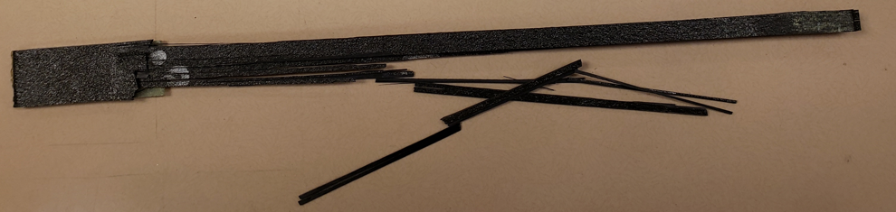

***Figure 12.*** *Picture of the 0° CFRP after testing.*

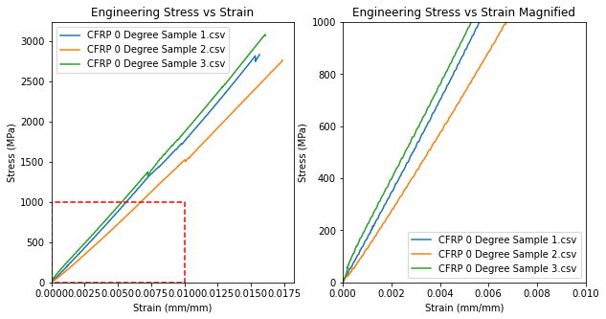

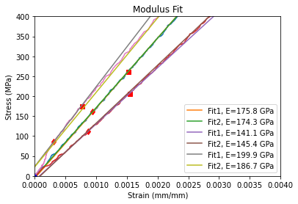

***Figure 13.*** *Plots of the stress-strain results for the 0° CFRP specimens along with fits for the modulus.*

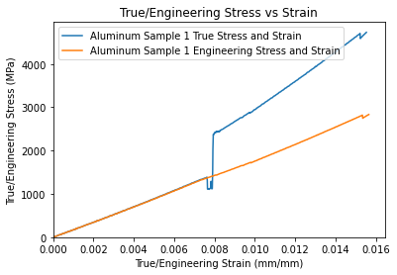

***Figure 14.*** *Representative plot of the engineering vs true stress-strain for 0° CFRP.*

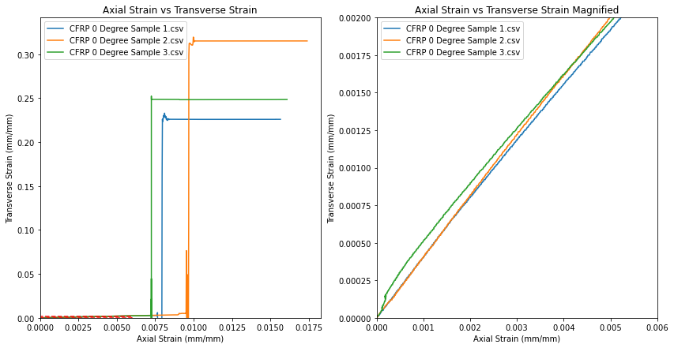

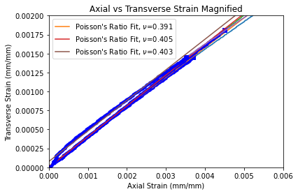

***Figure 12.*** *Representative plot of the axial vs. transverse strains of 0° CFRP along with a fit for Poisson’s ratio.*

Bar the yield strength the properties’ values and errors displayed in table 6 were calculated in the same manner as described in section 3.1. As this composite did not exhibit yielding before fracture, the yield and ultimate stress were taken to be the same. The density of the composite was found using the equation $ρ= ρ_{f}V_{f}+\left(1-V_{f}\right)ρ_{m}.$ The modulus of resilience was obtained by integrating the stress-strain curve of the specimen from zero the ultimate strain.

***Table 6.*** *Measured properties of the 0° CFRP.*

|  |  |
| --- | --- |
| **Properties** | **Values** |
| Young’s modulus, $E$ (GPa) | 179 ± 39.6 |
| Poisson’s ratio, $ν$ | 0.400 ± 0.006 |
| Yield Strength, $σ_{y}$ (MPa) | 2890 ± 137.9 |
| UTS (MPa) | 2890 ± 137.9 |
| Ultimate Strain, $ε_{ult}$ (mm/mm) | 0.0164 ± 0.000741 |
| % of elongation (%) | 0 |
| Specific stiffness, $E/ρ$ ($\frac{m^{2}}{s^{2}}$) | 112E9 ± 24.8E9 |
| Specific strength, $σ_{y}/ρ$ ($\frac{m^{2}}{s^{2}}$) | 1810E6 ± 86.5E6 |
| Fracture Stress (MPa) | 2890 ± 130 |
| Fracture Strain (mm/mm) | 0.0164 ± 0.00074 |
| Modulus of resilience (MPa) | 23.1 ± 1.06 |
| Tensile Toughness (MPa) | 23.2 ± 1.07 |

## 90º CFRP Results

In the tests for the 90° CFRP, the samples underwent no observable deformation before failure. The load-strain curve for each specimen was linear up to the point of fracture. The fracture occurred orthogonally to the direction of the loading as shown below.



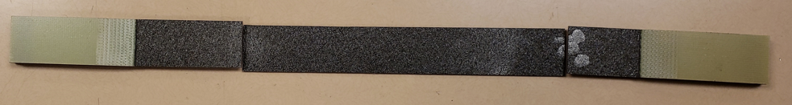

***Figure 13.*** *Pictures of the 90° CFRP before and after testing.*

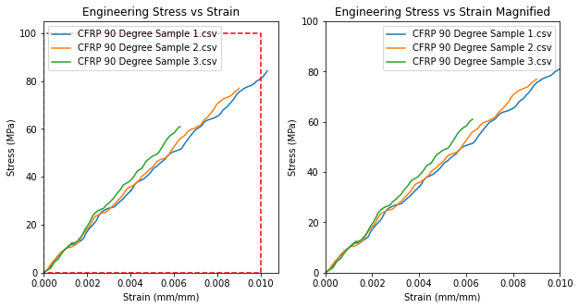

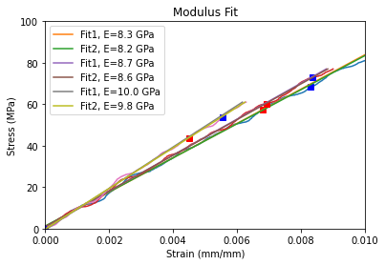

***Figure 14.*** *Plot of the stress-strain results for the 90° CFRP specimens along with a fit for the modulus.*

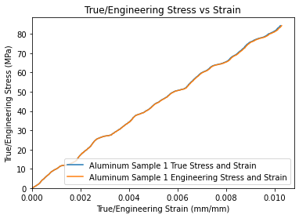

***Figure 15.*** *Representative plot of the engineering vs true stress-strain for 90° CFRP.*

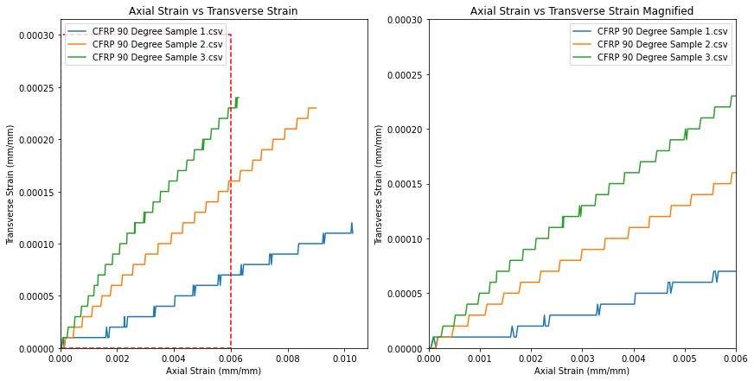

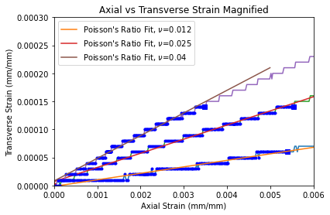

***Figure 16.*** *Representative plot of the axial vs. transverse strains of 90° CFRP along with a fit for Poisson’s ratio.*

Bar the yield strength the properties’ values and errors displayed in table 6 were calculated in the same manner as described in section 3.1. As this composite did not exhibit yielding before fracture, the yield and ultimate stress were taken to be the same. The density of the composite was found using the equation $ρ= ρ_{f}V_{f}+\left(1-V_{f}\right)ρ_{m}.$ The modulus of resilience was obtained by integrating the stress-strain curve of the specimen from zero to the ultimate strain.

***Table 7.*** *Measured properties of the 90° CFRP.*

|  |  |
| --- | --- |
| **Properties** | **Values** |
| Young’s modulus, $E$ (GPa) | 8.93 ± 0.703 |
| Poisson’s ratio, $ν$ | 0.0257 ± 0.0118 |
| Yield Strength, $σ_{y}$ (MPa) | 74.1 ± 9.72 |
| UTS (MPa) | 74.1 ± 9.72 |
| Ultimate Strain, $ε_{ult}$ (mm/mm) | 0.00852 ± 0.00167 |
| % of elongation (%) | 0 |
| Specific stiffness, $E/ρ$ ($\frac{m^{2}}{s^{2}}$) | 5.60E9 ± 0.441E9 |
| Specific strength, $σ_{y}/ρ$ ( $\frac{m^{2}}{s^{2}})$ | 46.5E6 ± 6.10E6 |
| Fracture Stress (MPa) | 74.1 ± 9.72 |
| Fracture Strain (mm/mm) | 0.00852 ± 0.00167 |
| Modulus of resilience (MPa) | 0.327 ± 0.103 |
| Tensile Toughness (MPa) | 0.331 ± 0.105 |

# Discussion

While the aluminum and steel specimens exhibited clear deformation via necking, the composite specimens did not visibly deform. The fracture surfaces of the aluminum and steel specimens were orthogonal to the axis and were distinctly ductile; the surfaces were rough and smaller in area than the initial cross-sectional area of the specimens. The fracture surface of the 0 degree CFRP was oriented along with the axis of the specimen and appeared abruptly and violently with no visual warning of failure. The fracture surface of the 90 degree CFRP was smooth and orthogonal to the axis of the specimen. The aluminum and steel specimens reached their maximum tensile stress prior to failure, while the CFRP specimens reached their maximum tensile stress at failure.

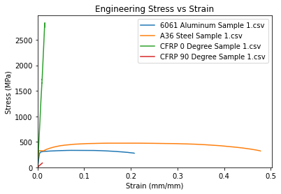

***Figure 17:*** *Plot of stress-strain curves from one of each of the four specimens.*

The correlation between the experimental and tabulated material properties varied greatly by material and individual property. The average experimentally obtained elastic modulus for 6061-T6 aluminum was 4.2% higher than the tabulated value. The average experimental poisson’s ratio was 5.2% lower than the tabulated value, and the experimental yield strength was 8.7% higher than the tabulated value. For the A36 steel the average experimental elastic modulus was 22.7% lower than the tabulated value, the experimental poisson’s value was 3.1% higher than the tabulated value, and the experimental yield strength was 33.6% higher than the tabulated value. For the 0 degree CFRP the experimental elastic modulus was 1.1% lower than the value calculated from equation 9, the experimental poisson’s ratio was 25% higher than the value calculated from equation 13, and the experimental failure strength was 26.6% lower than the value calculated from equation 11. For the 90 degree CFRP the experimental elastic modulus was 29.7% lower than the value calculated from equation 10, the experimental poisson’s ratio was 16.8% higher than the value calculated from equation 14, and the experimental failure strength was 28.0% lower than the value calculated from equation 12.

The errors between the experimental and tabulated properties are unreasonably large. For the elastic modulus only the tabulated values of 6061-T6 aluminum and the 0 degree CFRP fall within the error bounds of their respective experimental values. For the poisson’s ratio only the tabulated values of the A36 steel and 90 degree CFRP fall within the error bounds of their respective experimental values. All other tabulated values fall outside of the error bounds of their corresponding experimental values. Unless the tabulated material properties provided are erroneous, there were significant sources of error in either the execution of the tests or the analysis of the test data. A possible systematic source of error was failure to align the specimens properly with the axis of the applied loading. This would severely harm the integrity of the tensile test data. It is entirely possible the author of this report made a crucial error in the code used to analyze the test data and is unable to locate it. The provided error bounds for each property do not account for uncertainty in the dimensional measurements of each specimen, as their contribution was found to be insignificant. The author of this report wants to make it clear to the reader that they should not use the material properties experimentally calculated in this report for any design or analysis purposes as not only are the errors relative to tabulated values large, in some cases the error bounds for a property of a given material are too large to indicate that the experimental average can be utilized confidently.

The true and engineering stresses in this report were obtained using the same load data but different area data. The engineering stress in each specimen was calculated by dividing the instantaneous load by the initial cross-sectional area of the specimen, while the true stress was calculated by dividing the instantaneous load by the instantaneous cross-sectional area of the specimen. The true stress is useful to indicate the increasing strength of a ductile material as it necks and hardens due to the reorientation of crystalline structure in the direction of the applied force. This makes true stress more useful in the study of materials as strain hardening is accounted for. Engineering stress is more useful for design purposes, as an engineer only knows the original size of a part and the possible forces the part will be subjected to; they do not necessarily know how the part will deform under these forces. Engineering stress is also a more accurate figure for determining the failure strain of a material.

The behavior and failure mode of the 6061-T6 aluminum suggest it is of predominantly ductile nature. This ductile nature arises from the FCC crystal structure of aluminum, as FCC structures are closely packed atomic arrangements. This close packing enables more slip planes and makes the material more deformable [3]. The failure surfaces of the aluminum specimens were roughly perpendicular to the axis of loading and exhibited a rough surface with a cup and cone appearance. This is because ductile materials do not necessarily fail in the direction of the principal stress, but rather in the direction of maximum shear stress. The market value, ductile nature, and material properties of 6061-T6 aluminum suggest that it is a very versatile material and useful in applications where a high strength to weight ratio is desired. While the ultimate tensile strength of the 6061 is lower than the A36 steel, it has a much higher strength to density ratio. However, the low fracture stress and toughness indicate that this material should not be used in heavy-duty structural applications.

The behavior and failure mode of the A36 steel suggest it is of predominantly ductile nature. This ductile nature arises from the primarily BCC crystal structure of A36 steel [4]. BCC structures exhibit less slip planes than FCC structures, thus the A36 steel is harder and less malleable than the closely packed FCC structure of the aluminum. The failure surfaces of the steel specimens were similar to the failure surfaces of the aluminum specimens. The properties of A36 steel suggest that it is a strong but not very weight efficient material. This material has a very high toughness and stiffness, so we suggest that A36 steel be used primarily in structural applications.

The behavior and failure modes of the two different CFRP variations suggest that these materials are of predominantly brittle nature. This brittle nature derives from the polymer structure of the CFRP. The molecular strands in the CFRP used in this experiment do not experience much strain before failure. The failure surfaces of the 90 degree CFRP were perpendicular to the loading direction, while the failure surfaces of the 0 degree CFRP were aligned with the loading direction. This occurred because polymers are stronger in the direction that the molecular strands are primarily aligned. When the load was applied to the 90 and 0 degree CFRPs, the failure occurred in between molecular strands where the material was weakest. The 90 degree CFRP failed much easier than the 0 degree CFRP as the molecular strands were perpendicular to the direction of loading, while the molecular strands in the 0 degree CFRP were aligned with the direction of loading. Due to these properties, we recommend that CFRP be used in applications where loading is exclusively unidirectional and the molecular strands are aligned in the direction of loading.

# Conclusion

In this lab we experimentally determined various material properties of 6061-T6 aluminum, A36 steel, and carbon fiber reinforced polymers in two different orientations. The experimental values derived from the tensile tests did not correlate well with the provided tabulated data. It was found that 6061-T6 aluminum exhibits a good strength to weight ratio, while A36 steel exhibits high strength and toughness. The CFRP was demonstrated to be very rigid overall and very strong in the direction of fiber orientation. We recommend that due to the stark variance from tabulated data and large error limits in the experimentally derived material property values that the reader does not utilize our derived values in any serious design or analysis aspect. We also think that our results warrant further investigation into the properties of the materials we analyzed in this report.

# References

[1] ASTM D3039/D3039M, Standard Test Method for Tensile Properties of Polymer Matrix Composite Materials, Annu. B. ASTM Stand. (2014) 13.

[2] ASTM E8 / E8M-16a, Standard Test Methods for Tension Testing of Metallic Materials, Annu. B. ASTM Stand. (2016) 30.

[3] “Characteristics of the ductile failure,” *additive manufacturing testing, centro analisi materiali, tomografia industriale, ct inspection, ispezione raggi x, controlli non distruttivi, cnd*. [Online]. Available: https://www.tec-eurolab.com/eu-en/characteristics-of-the-ductile-failure.aspx. [Accessed: 12-Nov-2020].

[4] “Investigation of Phase Change in A36 Steel as a Result of High Velocity Impact Loading”, Slewa. M [Online]. Available: https://digitalscholarship.unlv.edu/cgi/viewcontent.cgi?article=1056&context=celebration

https://www.periodic-table.org/Aluminium-crystal-structure/

**Appendix**